Project Report on

**ELECTRIC CAR CONTROLLED BY BLUETOOTH**

Author

**Arifur Rahaman**

**Id :2014198642**

**Abstract :**.

In this project we make use of the Bluetooth technology to control our machine car. This machine can be controlled by any human using his android mobile phone, by downloading an app and connecting it with the Bluetooth module present inside our car. User can perform actions like moving forward, backward, moving left and right by the means of command using his-her mobile phone app. The task of controlling our car is taken car by the Arduino UNO with micro controller. Arduino play a major role in the control section and had made it easier to convert digital signals and analogue signals into physical movements. The major reason for using a Bluetooth based tech is that we can change the remote anytime – mobiles phones, tablets.

**INTRODUCTION :**

The main purpose of this project is to create a remote interface to control Robot with wireless technology. There is a need to communicate with a robot remotely to control the movement of robots and to transmit critical information in both ways. The aim of the project is to design an Arduino bot system and write a program on Arduino. Microprocessor. The Arduino car contains an Arduino microcontroller with basic navigation features. Arduino apps contain mediation instructions between Android controller and Arduino car. Android mobile controller uses various mobile sensors to monitor movement. An appropriate program in the arduino microprocessor to interact with the android controller has to be created.

The program will be complied through arduino IDE to the arduino microprocessor & loaded in to it after proper checking of logic to to minimize any hardware loss / damage. We will use a android application that will provide user an interface to interact with the arduino powered car. Arduino will be interfaced with Bluetooth module to establish the connectivity and it will also be attached with motor driver to control the motor speed. The user will have access to control the robot car using the Android programmed app. This robot car will move according to the instruction given through the Android application by the user. The proposed model of robot car will be operated on any kind of surface that is another advantage

**Objectives :**.

• We have used Arduino because it is an open source device which can be programmed

through any operating system like Windows, Mac, Linux, etc.

• The language used is understandable and easy.

• Arduino can be used by beginner in robotics to professionals.

• Changing of program is easy.

• Once a program is burned we don‘t need to worry about the program getting erased as

long as it is not reset.

friendly property.

**COMPONENTS :**

|  |  |
| --- | --- |
| Name | Descriptions |

|  |  |  |  |
| --- | --- | --- | --- |
| |  |  | | --- | --- | |  | Arduino UNO | | Arduino UNO R3 Development Board |
| Bluetooth Module | HC-05/HC-06 Bluetooth Module |
| Motor Driver IC | L293D H-Bridge Motor Driver IC |
| Motors | 12V DC Geared Motors, 300 RPM |
| |  |  | | --- | --- | |  | Battery | | 9V Rechargable Battery |
| Robot Chasis & Wheels & Screws | - |
| Connecting Wires | Jumper Wires |
| |  |  | | --- | --- | |  | Arduino UNO | | Arduino UNO R3 Development Board |

**Desciptions of product :**

## *Bluetooth Technology*

Bluetooth wireless technology is a short range communications technology intended to replace the cables connecting portable unit and maintaining high levels of security. Bluetooth technology is based on Ad-hoc technology also known as Ad-hoc Pico nets, which is a local area network with a very limited coverage. Bluetooth specification details the entire protocol stack. Bluetooth employs Radio Frequency (RF) for communication. It makes use of frequency modulation to generate radio waves in the ISM band. Bluetooth offers interactive conference by establishing an network .Bluetooth usage model includes cordless computer, intercom, cordless phone and mobile phones.

## *Arduino UNO Board*

The Arduino Uno is an [open-source](https://en.wikipedia.org/wiki/Open-source) [microcontroller board](https://en.wikipedia.org/wiki/Microcontroller_board) based on the [Microchip](https://en.wikipedia.org/wiki/Microchip_Technology) [ATmega328P](https://en.wikipedia.org/wiki/ATmega328P) microcontroller and developed by [Arduino.cc.](https://en.wikipedia.org/wiki/Arduino) The board is equipped with sets of digital and analog [input/output](https://en.wikipedia.org/wiki/Input/output) (I/O) pins that may be interfaced to various [expansion boards](https://en.wikipedia.org/wiki/Expansion_board) (shields) and other circuits. The board has 14 digital I/O pins (six capable of [PWM](https://en.wikipedia.org/wiki/Pulse-width_modulation) output), 6 analog I/O pins, and is programmable with the [Arduino IDE](https://en.wikipedia.org/wiki/Arduino#Software) (Integrated Development

## *L293D Motor Drive H-Shield*

The Motor Driver is a module for motors that allows you to control the working speed and direction of two motors simultaneously This is designed to provide bidirectional drive currents at voltages from 5 V to 36 V. Rotation of motor depends on Enable Pins. When Enable 1/2 is HIGH , motor connected to left part of IC will rotate according to following manner

**BLOCK DIAGRAM:**

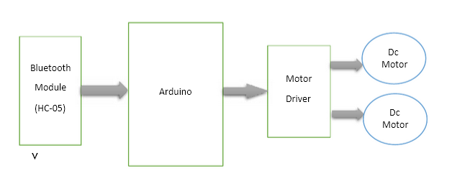

**Circuit Diagramme :**

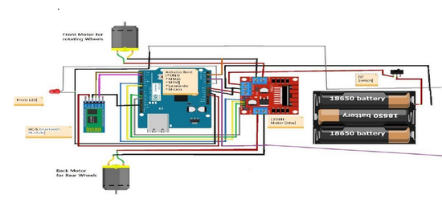



**Implementation :**

The Motor driver of the car is connected to arduino to run the car. The driver's input pins are connected to the arduino digital pins. Here we have used two DC motors to driver car in which one motor is connected at output pin of motor driver and another motor is connected with rest pins. Battery is used to power a motor driver to drive motors. Bluetooth module’s rx and tx pins are directly connected to tx and rx of the Arduino. And the vcc and ground pin of Bluetooth module

is connected to +5 volt and Arduino ground. And a 9 volt battery is used to power the circuit in arduino's Vin pin. The Bluetooth-enabled car will move with the touch button on the Android Bluetooth mobile app. To run this project first we will need to download the Bluetooth app from Google Play Store. We may use any Bluetooth device that will support or send the data.

RC module is the main working unit of this system. This unit consists of the Arduino chip, the motor drivers, and a Bluetooth module connected to the circuit. L298N Motor driver are used to control the dc motors. The RC unit is powered using 6V battery connected to this Arduino chip. The Paper on Android Controlled Arduino based Robotic Car for controlling the module is received using Bluetooth module HC-05. After simulating the circuit connections, we have programmed the arduino uno. Connections were made as per the circuit diagram and the file of the code of arduino was attached to the Arduino uno. An appropriate program in the arduino microprocessor to interact with the android controller has to be created. The program has been successfully complied through arduino IDE to the arduino microprocessor & loaded in to it after proper checking of logic to decrease any loss/damage of hardware.

Final product :

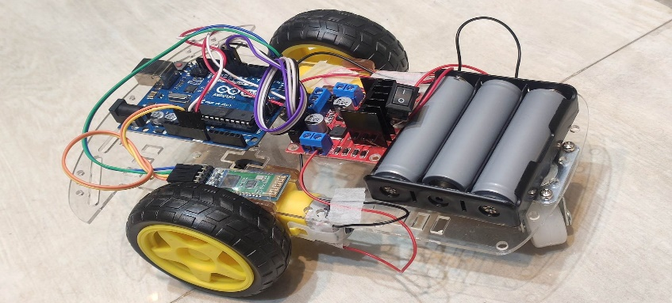

**ARDUINO CODE :**

#define in1 12

#define in2 11

#define in3 10

#define in4 9

int command;

int Speed = 204;

int Speedsec;

int buttonState = 0;

int lastButtonState = 0;

int Turnradius = 0;

int brakeTime = 45;

int brkonoff = 1; //1 for the electronic braking system, 0 for normal.

void setup() {

pinMode(in1, OUTPUT);

pinMode(in2, OUTPUT);

pinMode(in3, OUTPUT);

pinMode(in4, OUTPUT);

Serial.begin(9600);

}

void loop() {

if (Serial.available() > 0) {

command = Serial.read();

Stop();

switch (command) {

case 'F':

forward();

break;

case 'B':

back();

break;

case 'L':

left();

break;

case 'R':

right();

break;

case '0':

Speed = 100;

break;

case '1':

Speed = 140;

break;

case '2':

Speed = 153;

break;

case '3':

Speed = 165;

break;

case '4':

Speed = 178;

break;

case '5':

Speed = 191;

break;

case '6':

Speed = 204;

break;

case '7':

Speed = 216;

break;

case '8':

Speed = 229;

break;

case '9':

Speed = 242;

break;

case 'q':

Speed = 255;

break;

}

Speedsec = Turnradius;

if (brkonoff == 1) {

brakeOn();

} else {

brakeOff();

}

}

}

void forward() {

analogWrite(in1, Speed);

analogWrite(in3, Speed);

}

void back() {

analogWrite(in2, Speed);

analogWrite(in4, Speed);

}

void left() {

analogWrite(in3, Speed);

analogWrite(in2, Speed);

}

void right() {

analogWrite(in4, Speed);

analogWrite(in1, Speed);

}

void Stop() {

analogWrite(in1, 0);

analogWrite(in2, 0);

analogWrite(in3, 0);

analogWrite(in4, 0);

}void brakeOn() {

buttonState = command;

if (buttonState != lastButtonState) {

if (buttonState == 'S') {

if (lastButtonState != buttonState) {

digitalWrite(in1, HIGH);

digitalWrite(in2, HIGH);

digitalWrite(in3, HIGH);

digitalWrite(in4, HIGH);

delay(brakeTime);

Stop();

}

}

lastButtonState = buttonState;

}

}

void brakeOff() {

}

**Output validation :**

In this project we have controlled the robot using Android Phone by using a Bluetooth Controller application which we got from Android Play store. By installing the application we were able to move the robot in four directions. Upon clicking the "FORWARD ARROW", the data "Forward" is sent to car moves FORWARD. Upon clicking the "BACKWARD ARROW", the data "Backward" is sent to the connected. Bluetooth Module and the car moves BACKWARD. Upon clicking the "LEFT ARROW", the data "Left" is sent to the connected Bluetooth Module and the car turns LEFT. Upon clicking the "RIGHT ARROW", the data "Right" is sent to the connected Bluetooth Module and the car moves RIGHT. When we touched forward button in Bluetooth controller app then car started moving in forward direction and moving continues forward until next command comes.

**Conclusion**

The aim of the project was to create an arduino integrated car that has to be controlled through an application that runs on the android operating system. The constraints square measure met and overcome with success. The system is intended as find itirresistible was set within the design section. Validation checks iatrogenic have greatly reduced errors. Provisions are created to upgrade the code. The applying has been tested with live information and has provided a prosperous result. Thence the code has proven to figure expeditiously. The system created met its objectives, by being straightforward to use, implement and secure. This code is developed with measurability in mind. Further modules may be simply other once necessary. The code is developed with standard approach. All modules within the system are tested with valid information and invalid information and everything work with success.